Outdoor Play and Learning Policy
Our Lady of the Visitation Catholic Primary School



Approved by: | Policy Committee
Last reviewed on: | Spring 2026
Next review due by: | Summer 2027

Introduction to this Policy
Pupils follow the Gospel Values and Ethos of the school in the ways they play and interact with each other
‘Play is essential for children's well-being and development. When planning and providing play opportunities, the aim is not to eliminate risk but to balance risks and benefits. No child will learn about risk if they are wrapped in cotton wool’ (Health and Safety Executive, 2012)
Children have rights enshrined in the United Nations Convention on the Rights of the Child (UNCRC, 1989). Those rights are concerned with freedom and protection to access and do the things that make life worth living. Article 31 of the UN Convention acknowledges that all children have a right to play. At Our Lady of the Visitation, we recognise that play is an essential part of a happy and healthy childhood. We aim to provide high-quality, enjoyable play experiences for all children across the school.

We will do this by providing carefully considered outdoor spaces, play structures and resources that offer a rich choice of accessible play experiences for every child. We will refer to this play policy in all decisions that affect our children's play. We are committed to providing the strategic and operational leadership needed to provide and maintain quality play provision for all our children. The Health and Safety Executive (HSE) supports the provision of diverse play environments, recognising that well-managed spaces may involve some degree of risk and occasional danger and that safety concerns should not create restrictive environments that limit challenge, preventing children from expanding their learning and capabilities (HSE, 2012). This policy provides a framework for supporting play and making decisions about the associated risks.

To support the development of high-quality play times, our school has invested in the Outdoor Play and Learning (OPAL) Programme, providing us with a tried and tested framework for improving children’s opportunities for play. We will be following the principles and practices recommended by OPAL, as we seek to ensure every child in our school has an amazing play time every day.

- Rationale
Our school believes that all children need opportunities to play that allow them to explore, manipulate, experience and affect their environment.

We do this through a commitment to The OPAL Primary Programme. The rationale of the programme is that “… better, more active and creative playtimes can mean happier and healthier children, and having happier, healthier, more active children usually results in a more positive attitude to learning in school, with more effective classroom lessons, less staff time spent resolving unnecessary behavioural problems, fewer playtime accidents, happier staff and a healthier attitude to life.”
The ethos of the OPAL programme links with our school values and gives
opportunities for pupils to demonstrate and develop their creativity, resilience and sense of community.

- Definition and value of play

Play is defined as a process that is intrinsically motivated, directed by the child and freely chosen by the child. Play has its own value and provides its own purpose. It may or may not involve equipment or other people.
We believe play has many benefits, including:
● Play is critical to children’s health and wellbeing, and essential for their physical,
emotional, social, spiritual and intellectual development.
● Play enables children to explore the physical and social environment, as well as
different concepts and ideas.
● Play enhances children’s self-esteem and their understanding of others through freely chosen social interactions, within peer groups, with individuals, and within groups of different ages, abilities, interests, genders, ethnicities and cultures.
● Play requires ongoing communication and negotiation skills, enabling children to
develop a balance between their right to act freely and their responsibilities to others.
● Play enables children to experience a wide range of emotions and develop their ability to cope with these, including sadness and happiness, rejection and acceptance, frustration and achievement, boredom and fascination, fear and confidence.
● Play encourages self-confidence and the ability to make choices, problem solve and to be creative.
● Play maintains children’s openness to learning, develops their capabilities and allows them to push the boundaries of what they can achieve.

- Aims

At Our Lady of the Visitation, our mission is to provide playtimes that facilitate fun, creativity exploration and spiritual develop through awe and wonder, for every child, every day! Pupils will follow the Gospel Values and Ethos of the school in the ways they play and interact with each other.

In relation to play, our school aims to:
● Aid children’s physical, emotional, social, spiritual and intellectual development.
● Ensure play settings provide a varied, challenging and stimulating environment.
● Provide a range of environments that will support children’s learning across the
curriculum and learning about the world around them.
● Promote independence and teamwork within children.
● Build emotional and physical resilience.
● Have resources and processes in place that mean children can play outside in all
weathers as we recognise the physical and mental benefits of playing outside, in all
seasons.
● Provide a range of environments that will encourage children to explore and play
imaginatively and develop their creativity.
● Support children in showing compassion and understanding through their play and
interactions with each other in a variety of contexts.
● Allow children to take risks and use a common-sense approach to the management of
these risks and their benefits, thus developing their courage.
● Enable children to develop respect for their surroundings and each other.
● Provide opportunities for children to develop their relationships within peer groups,
with individuals, and within groups of different ages, abilities, interests, genders,
ethnicities and cultures, thus deepening our sense of community.

- Working Group Membership

As a school, we will also maintain an OPAL working group, which will oversee the implementation of the OPAL Programme, ensuring that all aspects of school life that influence our play times are aligned with the aims and aspirations of this policy.

The OPAL Working Group (maintains a whole school approach to play times) and consists of:

- The Headteacher
- The Governor Play Champion
- The Parent Play Champion
- Curricular Lead for Play (oversees the development of play times)
- Play Coordinator (oversees the delivery of play times)

Play times are facilitated by the Play Team with direction from the Play Coordinator and Working Group.

- Rights

Our school recognises the UN Convention on the Rights of the Child, which includes the right to play, recreation and leisure (Article 31) and the right of children to be listened to on matters important to them (Article 12). We acknowledge that we have a duty to take these rights seriously and listen to children’s views on their play.

We will do this by ensuring that pupils’ play time is protected as far as possible and that their input and voices are heard through regular play assemblies, pupil voice and school council.

- Benefit and risk
Risk refers to the uncertain outcomes of a situation and is often associated with negative consequences. However, risk can also bring positive benefits. For example, balancing along a wall may result in physical injury, but it can also generate pleasure, excitement, self-awareness, confidence, risk perception and management skills, and a sense of achievement. (See Appendix 1)
In the UK, the provision of play opportunities is governed by the Health and Safety at Work Act (1974), the Management of Health & Safety at Work Regulations (1992), and the Occupiers’ Liability Acts (1957, 1984). These laws require providers to:
- Reduce risks "so far as is reasonably practicable" (H&S at Work Act 1974),
- Ensure visitors are "reasonably safe in using the premises" (Occupiers Act, 1984),
- Manage and assess risks appropriately and proportionately (Management of Health & Safety at Work Regulations, 1992).
The level of risk children should be exposed to is a question of what is reasonable and practicable. Unlike occupational health and safety, where risk elimination may be favourable, for those involved in children's play, balancing risks and benefits is the primary goal (i.e. what is reasonable and practicable in the context of children’s play is different to a workplace). The Health and Safety Executive highlights this in its high-level statement, Children’s Play and Leisure – Promoting a Balanced Approach¹:
‘Striking the right balance between protecting children from the most serious risks and allowing them to reap the benefits of play is not always easy. It is not about eliminating risk. Nor is it about complicated methods of calculating risks or benefits. In essence, play is a safe and beneficial activity. Sensible adult judgements are all that is generally required to derive the best benefits to children whilst ensuring they are not exposed to unnecessary risk.’
In 2023, the International Organisation for Standardisation (ISO) also adopted this approach as a best practice for managing risks in sports and recreation (including play) facilities. The ISO uses the term "benefit-risk assessment", but both terms mean the same thing. ISO 4980:2023 defines this as:
‘A form of risk assessment that considers both risks and benefits in parallel when making decisions. Benefit-risk assessment is a balanced approach involving judgment based on clear values and understandings. Where appropriate, it takes account of local circumstances and includes an evaluation of social, physical, and developmental considerations.’
We will use a risk-benefit approach when making decisions about what is reasonable and the desirability of children engaging with heightened levels of risk. This approach aims to ensure that children can experience the benefits of uncertainty in their play while seeking to reduce the risk of serious harm and those risks that are not beneficial to children. This decision-making will be based on evaluating:
- The benefits of the activity (e.g., skill development, resilience, confidence).
- The likelihood and severity of harm.
- Expert guidance, best practices, and comparative examples.
- The impact of restrictions on play quality and its associated benefits.

Strategic Risk Management
Our risk management strategy is an ongoing process informed by OPAL’s R.A.P.I.D. approach to risk management in play. R.A.P.I.D. stands for Risk-benefit assessments, Assemblies, Policy, Inspections, and Dynamic risk management. These different elements of our risk management strategy work together (as depicted in the diagram below), ensuring we have robust systems in place to support good decision-making and the ongoing maintenance of a ‘safe enough’ environment for play.
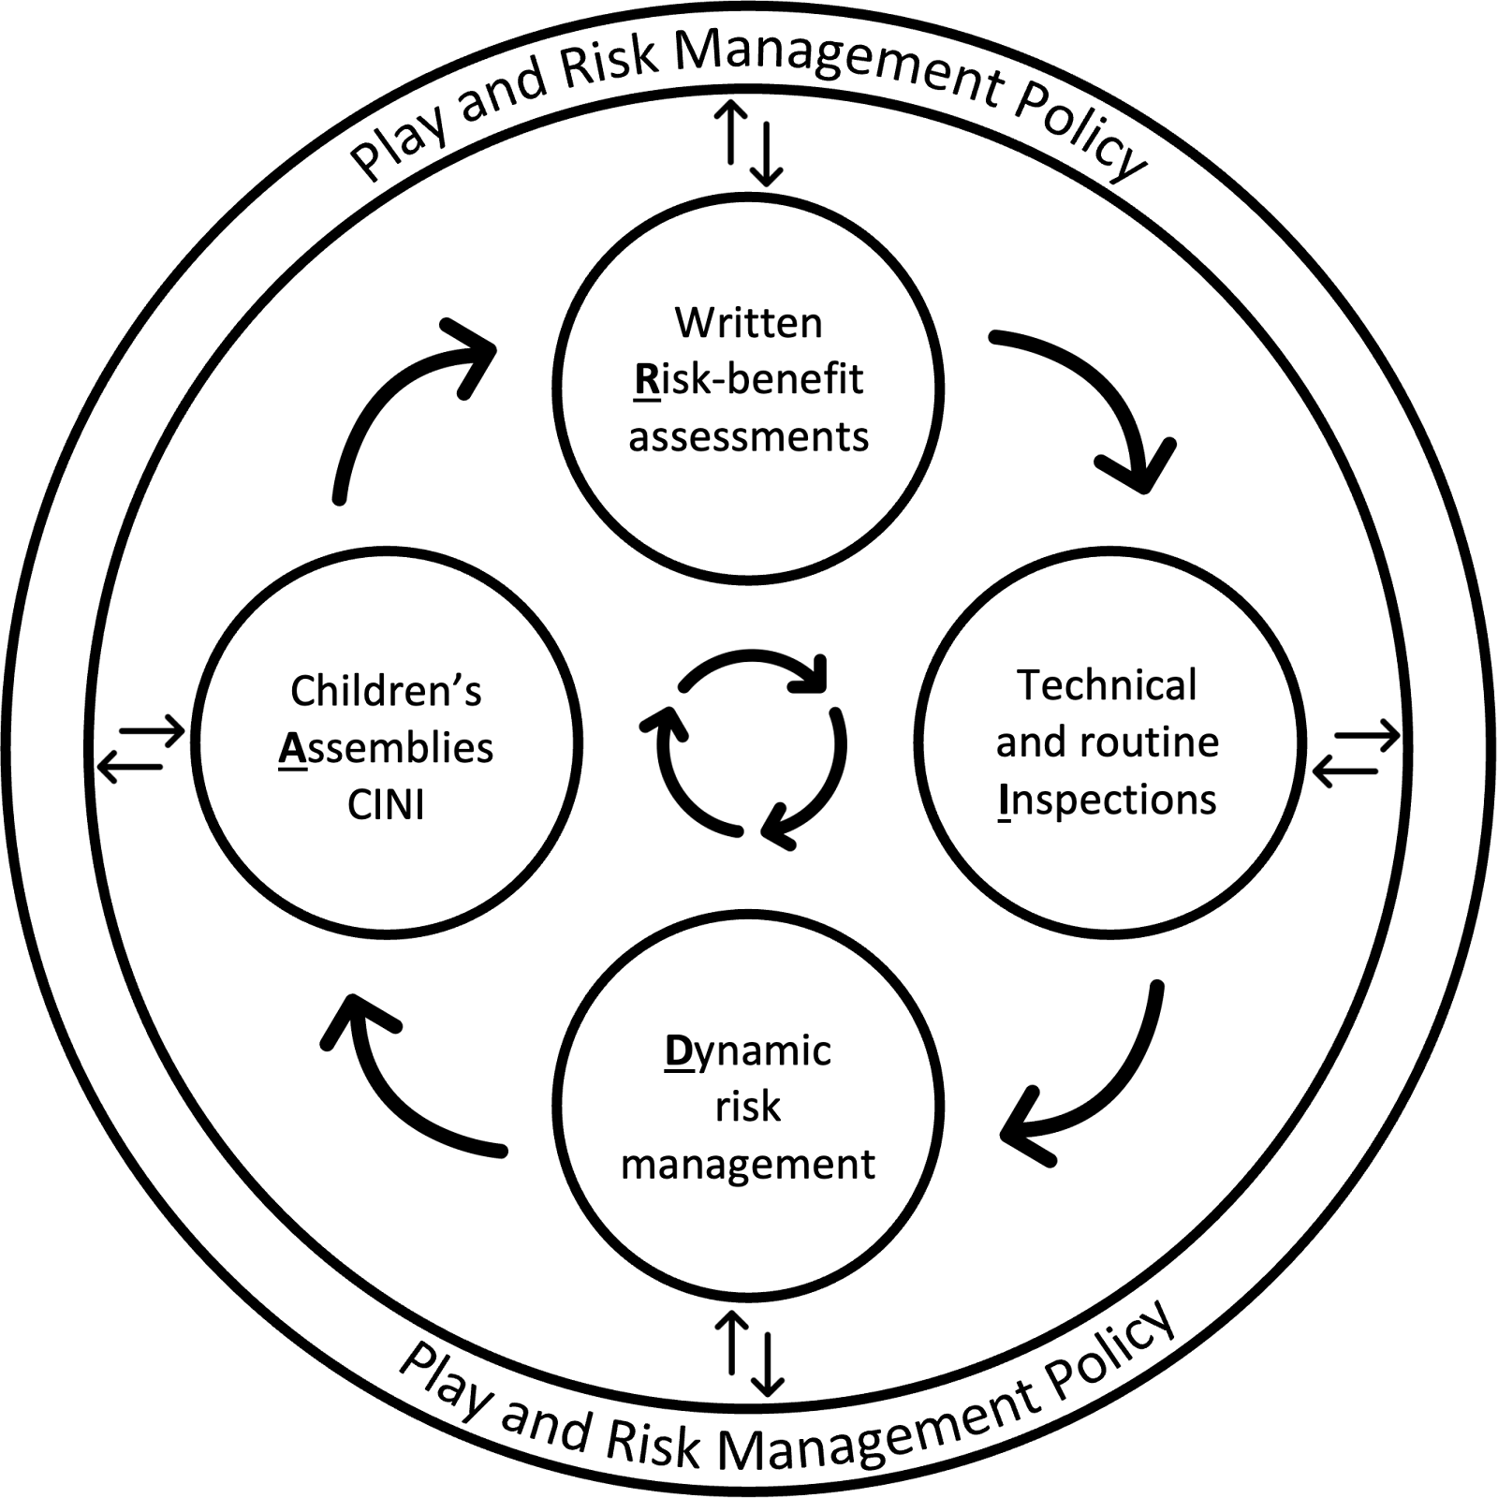
Following HSE guidance (see Appendix 2), we recognise that detailed risk-benefit assessments for every scenario are unnecessary, impractical, and time-consuming. Instead, we take a proportionate and balanced approach to risk assessment, ensuring that higher-risk activities receive greater scrutiny but low-risk opportunities (whilst still subject to professional judgement), remain unburdened by excessive paperwork.
We use the Tolerability of Risk Framework (diagram below) to guide professional judgements about the opportunities we provide, and the level of risk management required. The broadly acceptable region refers to opportunities where the risk is perceived to be low enough to be acceptable to most people without the need for a detailed risk-benefit assessment. For play opportunities that are considered to fall into this lowest region, this play and risk management policy represents an overarching risk-benefit assessment for our play time provision. Sections of this policy take account of the behavioural characteristics of children’s play, their associated benefits and risks, and describe approaches and systems for managing the everyday play behaviours that are likely to occur in our play environment/s.

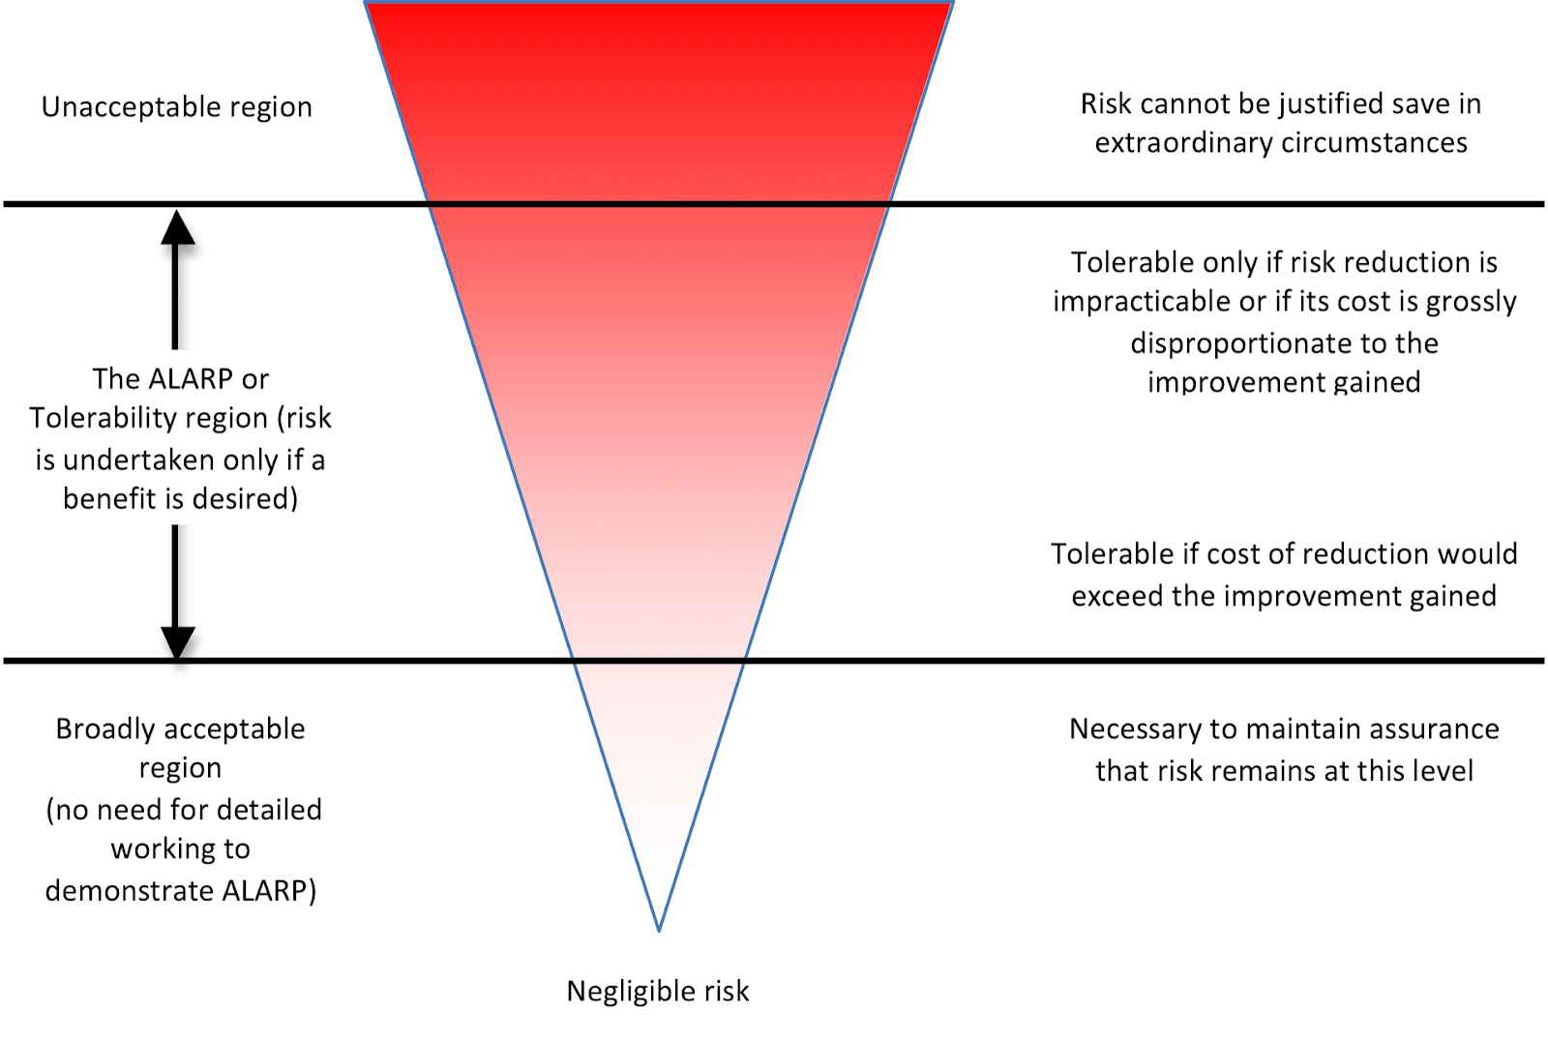
When planning for play, any environmental feature or opportunity that we deem to present a level of risk beyond the broadly acceptable region will be subject to its own detailed risk-benefit assessment. This assessment will evidence our decision-making processes and set out actions to manage the associated risks so that they remain as low as is reasonably practicable (whilst maintaining the benefits of play). This might include situations where:

- Play structures, site-specific features, or impact surfaces fall outside of commonly accepted standards (for example, the European Standards for Fixed Play Equipment and Impact Attenuating Surfaces).
- Through adults’ actions, children are exposed to a greater risk of injury than they might normally encounter of their own volition.
- Staff are unsure about the risks involved and how to manage them (the process of completing risk-benefit assessments can aid discussion and provide greater clarity and confidence).
- Staff feel additional justification is required due to concerns about how risks may be perceived by the public.
There will also be situations where children, during play, create their own heightened levels of risk which adults may not have planned for. In such situations, risk-benefit assessments may be applied in two ways:
- Routine play opportunities with heightened levels of risk - if a play opportunity is regularly occurring (e.g., most days or weeks), it should undergo a written risk-benefit assessment.
- Novel play opportunities with heightened levels of risk - when such play opportunities emerge spontaneously, such as something children invent in the moment, a dynamic risk-benefit assessment should be applied.
Our written risk-benefit assessments will be regularly reviewed and updated based on experience, knowledge, and new evidence, ensuring they remain effective and proportionate.
Dynamic Risk-Benefit Assessment
Children’s play is inherently exploratory, flexible, and varied. While playing, children naturally seek uncertainty, which means risks can emerge in the moment. To manage these ‘real-time’ risks, we adopt a dynamic risk-benefit assessment approach, where staff assess risks as they arise, considering the environment and play context to determine the most appropriate response.
Risk perception is subjective, and individual staff may differ in their tolerance of risk. To support consistency in decision-making, we have adopted guidance on dynamic risk-benefit assessments (see Appendix 1), supporting staff in making balanced and informed choices.
Our approach aims to balance intervention with the benefits of freedom and uncertainty in play. Whenever possible, staff should observe how children navigate risks for themselves before deciding if intervention is necessary. In doing so, staff should consider:
- Children’s self-management of risk – Have they removed hazards, adjusted their behaviour, or set their own safety rules?
- Contextual factors – Are children adapting to different ages and abilities while keeping risks balanced with benefits?
- Intervention necessity – If intervention is needed, it should aim to preserve play benefits while reducing the level of risk. Staff should stop activities only in cases of imminent and serious harm.
When staff make a dynamic risk-benefit assessment that enables a higher-risk opportunity, they will reflect on these experiences with peers in team meetings and, where necessary, integrate them into routine risk-benefit assessments or inform staff training and development opportunities.
Good and Bad Hazards
In making risk-benefit decisions, we will use the concept of good and bad hazards, recognising that the type of hazards children should be exposed to depends on what is both reasonable and practicable, and of benefit to children.
- Acceptable/Good Hazards – objects or situations where the associated risks can reasonably be foreseen by children and which offer potential benefits to children when encountered or navigated. We aim to manage these hazards, so the risks remain at a reasonable level.
- Unreasonable/Bad Hazards – objects or situations where children cannot reasonably be expected to recognise the associated risks, with those risks also offering little to no benefit. While absolute protection is impossible, we aim to protect children from hazards that pose an unreasonably high risk of serious injury, in line with reasonable safety measures.
Inspection and Maintenance
We conduct regular inspections of the play environment and resources to ensure risks remain at a reasonable and acceptable level. This includes:
- Daily/weekly site inspections – visual checks of the play environment, its features, structures and equipment.
- Routine inspections of play resources – visual checks of loose parts on an agreed schedule to ensure they are safe enough for use in play.
- Monthly/quarterly site inspections – more in-depth checks involving closer inspection of moving parts and structural integrity, ground conditions, and natural features that may require attention due to growth or decay.
- Annual inspections – formal and thorough inspections of engineered play equipment, self-built structures and tree conditions, often carried out by an external party.
Throughout these inspection processes, hazards that are not beneficial to play should be removed, taken out of use, and/or scheduled for repair/maintenance as appropriate.

- Supervision

The law requires that children in school have supervision but for primary school playtimes there are no stated ratios. During the school day there should be one or more adults present outdoors. The school recognizes OPAL’s three models of supervision: Direct, Remote and Ranging. Except for new children in reception, whose skills and orientation in the school environment need to be assessed, the school does not believe direct supervision is possible or beneficial. Supervisors will use ranging and remote supervision models, so that children can quickly find an adult and adults can patrol large sites to gain an awareness of the kinds of play and levels of risk likely to be emerging.

Each member of the Play team are allocated to a zone of the playground each week. It is their responsibility to ‘walk the zone’ before the children come out to do general safety checks, identify/remove any unwanted risks and set up resources. Whilst children are at play, each member of the play team will be ranging through their allocated zone and performing dynamic risk assessments as to where they spend more time within the zone depending on the number of pupils in that area and the type of play being carried out at that time. Each zone overlaps so effective communication between staff outside mean that extra support can be given when needed.

- The Play Team Structure and roles

The curricular lead for play works with the play team to ensure the school is facilitating high quality playtimes for all our pupils. Meetings are held regularly to look at what opportunities we are providing for our pupils to develop a variety of different play skills and how we can further change and develop our offer.

The play coordinator supports and facilitates meaningful and productive child-initiated play during the school day.

Our Play team have all carried out training around essential playwork skills. Staff will use and refer to the Playwork principles when appropriate interventions are needed, and ultimately will strive for facilitating an environment that nurtures children’s self-directed play.

Staff who are new to playwork will receive an induction to the key principles on starting the role and then undertake further training over time.

The Play Team’s core function is to create an environment that will stimulate children’s play and maximise their opportunities for a wide range of play experiences, following the play work principles (see Appendix 2). A skilled and experienced playworker is capable of enriching the child’s play experience both in terms of the design and resources of the physical environment and in terms of the attitudes and culture fostered within the play setting.

Playworkers are a channel of access to new materials and tools and they can act as a stimulus to children to explore and learn. They are also available to participate in the play if invited. (See Playwork Principles appendix 3)

- Whole school communication
At Our Lady of the Visitation, we are fully committed to working with children to provide the play experiences that they want and need in their school. We will maintain an open dialogue with children about our play provision, with the aim of further developing their playtime experiences using their voices and ideas as guidance.
Play assemblies are a key aspect of our risk management strategy. This includes meeting with children at least once per half term and discussing with them the play opportunities on offer, the play environment and their play behaviours, as well as our approach to working with play. We use OPAL’s C.I.N.I format, which incorporates Celebrating children’s play, Informing children about aspects of our play provision, Negotiating with children about aspects of the play offer, and Innovating with children about improving our play offer. These assemblies routinely include conversations with children around various aspects of risk management.
As a school, we will maintain the OPAL working group, which will oversee the implementation of the OPAL Programme, ensuring that all aspects of school life that influence our play times are aligned with the aims and aspirations of this policy.

Appendix 1
Dynamic Risk Benefit Assessment Flow Chart

Appendix 2
Health & Safety Executive: Children’s Play and Leisure – Promoting A Balanced Approach

Appendix 3
The Playwork Principles

