

WHAT AN AMAZING ACHIEVEMENT!
We are so proud of all our children for the effort they have put into the recent times table competition. This was a home learning activity that required a lot of support from parents/carers so we thank you also for your efforts.
We are delighted to announce that we had three winners from our school.
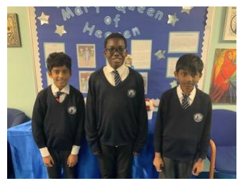
Congratulations to Krisban 6W for securing the 35th spot nationally among 258,458 participants in the TTRS
Competition 'NSPCC Rocks' in February. We are immensely proud of Krisban's remarkable accomplishment.
Well done to Harish 5Y for attaining the 13th position among 39,812 students in Greater London, and to Micaiah 5Y for securing the 14th position.
Congratulations to 5Y who had the most children enter the competition and to Our Lady of the Visitation Catholic School for achieving 10th place among 475 schools in Greater London.
We are TIMES TABLE ROCK STARS!

